Mysticetus Theodolite User Guide

Contents

Version Information 2

Introduction 2

Standard Operating Procedures (SOP) 4

**Theodolite Integration with Mysticetus** 4

**Equipment and Materials** 5

**Project Setup & Configuration** 6

**Mysticetus Software Configuration & Testing** 7

**Data Collection & Validation –** 8

Details 10

**Project hierarchy** 10

**Theodolite Communication Setup** 12

Detailed Discussion on Steps in the SOP 13

**Reference Points Determination** 13

**Create Horizontal and Vertical Reference Points** 14

**Enabling Waypoint Creation in Mysticetus** 15

**Creating Waypoints in Mysticetus** 17

**Theodolite Connect, Configure, and Definition Within Mysticetus.** 22

**Creating a Theodolite in Mysticetus** 24

**Communication Test** 28

**Theodolite Calibration Horizontal Reference (Daily)** 30

**Theodolite Calibration – Altitude Calibration (periodically)** 33

**Change Logging – Recording Theodolite Height Updates** 36

**Troubleshooting Erroneous readings** 38

**Important points for theodolite operation** 39

Technical Discussion on Reference Points, The Why 40

**Vertical Reference Point Discussion** 40

**Horizontal Reference** **Point Discussion** 41

**Additional Setting Options for DT205:** 44

**Theodolite Manuals** 44

**References** 44

Appendix 45

Checklists – 45

# Version Information

|  |  |
| --- | --- |
| **Version** | **Notes** |
| 2024.12 | General edits, add versioning table, checklists, and some formatting. |
| 2025.01 | General edits, language cleanup, and call for finding user manual. |
| 2025.02 | Clarification to language in SOP and SOP detailed section |
| 2026.01 | Minor clarifications to equipment list |

# Introduction

Configuring the Theodolite for running on Mysticetus has specific steps required. Not following these steps will result in frustration, time loss, angry calls to us, and general sleep deprivation. Please read this carefully.

This manual explicitly references the Sokkia (Topcon) DT205 which is now out of production according to their website. The newer model, 300, is currently being evaluated for being a suitable replacement.

Figure Drawing courtesy of Scotti-Lynn

These procedures are correct for all Mysticetus supported theodolites. Direct support currently only exists for the Topcon (also known as Sokkia) theodolites equipped with the RS232 communications port. Some examples below directly apply to the Topcon DT205 which is still commercially available as of 2024. Today, other devices can be used with manual data entry – reach out to us for more information.

Figure Image taken from the Topcon 200/200L series user manual emphasis here is the RS-232C connector.

# Standard Operating Procedures (SOP)

## **Theodolite Integration with Mysticetus**

**Purpose**

This Standard Operating Procedure (SOP) outlines the procedures for integrating a theodolite (DT205) with the Mysticetus platform for accurate data collection during offshore operations. Adherence to this SOP ensures data integrity, consistency, and compliance with project requirements.

Details for the major steps in the SOP are provided further in this document. Once familiar with the overall process outlined in the detailed section, daily setup and data collection should flow readily.

A simplified checklist is in the appendix of this document.

**Scope**

This SOP applies to all personnel involved in setting up, calibrating, and operating the theodolite in conjunction with the Mysticetus software platform.

**Responsibilities**

* **Field Observers:** Responsible for executing the field setup, calibration, and data collection procedures outlined in this SOP.
* **Data Analysts:** Responsible for quality control and analysis of the data collected within the Mysticetus platform.
* **Project Manager:** Responsible for ensuring that all personnel involved are trained in this SOP and that the necessary equipment and resources are available.

## **Equipment and Materials**

* Theodolite
* Windows Laptop or ruggedized tablet (preferred) with Mysticetus software installed.
* Mysticetus software license from Mysticetus.
* Extension cord for power of sufficient length
* High-accuracy GPS device such as a Garmin Etrex 22
* Sturdy Tripod
* Power supply for theodolite and laptop
  1. Theodolite will likely need rechargeable batteries
* Nine pin connector to RS232 cable from manufacturer
* RS 232 to USB cable such as Trendnet which has known good Windows driver support
* This Theodolite user manual
* Portable table and chair(s) for the computer is recommended
* Two person team – one to sight the animal and give verbal description, the other to record that information

## **Project Setup & Configuration**

**Many steps below are one-time tasks.**

**Basic Tasks**

1. **Project Hierarchy:** Verify the correct project hierarchy (Grandparent > Parent > Child) or Child only within Mysticetus. Consult with Mysticetus for details.
2. **Theodolite user manual:** Source the correct user manual for your theodolite. We have many of them but not all. Do ask.
3. **Theodolite Communication Setup:** Configure the theodolite’s communication settings according to the manufacturer's instructions (refer to the theodolite user manual). This is a one-time setup per theodolite only.

**Field Setup (for each observation location)**

* 1. **Reference Points Determination:** Establish precise vertical and horizontal reference points. Use a high-accuracy GPS device to acquire latitude/longitude coordinates for these points. Remember this data for creation of waypoints in Mysticetus.
  2. **Theodolite Placement (daily):** Securely mount the theodolite on a tripod in a stable location with an unobstructed view of the observation area and the reference points.
     1. Level the theodolite.
     2. Refresh batteries as required.
     3. Connect 9 pin cable to theodolite.

1. **Theodolite Location Determination (daily):** Determine the precise latitude/longitude coordinates of the theodolite location. Use a high-accuracy GPS device.

## **Mysticetus Software Configuration & Testing**

1. **Verify Mysticetus Off:** Shut down the Mysticetus program.
2. **Com Port Identification:** Connect the RS232 cable assembly to the laptop and theodolite. Turn on theodolite. Identify its assigned Com port *without* Mysticetus running using Windows “Device Manager” application.
3. **Waypoint Definition in Mysticetus:** Launch Mysticetus in *Advance* *Editor Mode in the parent project* (review project architecture). Define the horizontal and vertical reference points as "Waypoints" within Mysticetus. Name them and input the latitude/longitude values for each.
4. **Theodolite Configuration in Mysticetus:** Configure the theodolite Com port and communication speed (baud rate) within the configuration “this machine tab”. Always plug the USB cable into the same USB port on the laptop to keep com port the same.
5. **Theodolite Definition in Mysticetus:** Create the theodolite as a "Vehicle" within the Mysticetus. Name it and input (or update) the latitude/longitude values.
6. **Save/Deploy template:** If project is in a grandparent/parent/child then save project and deploy updates to child project, otherwise Simply save your template.
7. **Switch to the Child project:** Once the updated template has deployed successfully to the child then switch to that child project. Mysticetus will restart with the child project loaded.
8. **Set your primary vehicle:** Right click on the vehicle and set as primary vehicle
9. **Mysticetus Data Collection Mode:** Exit Mysticetus in Advance Editor mode, verify theodolite is turned on, and start Mysticetus in Data Collection mode.
10. **Communication Test:** “Test Theo” tests the communication link between Mysticetus and theodolite. Compare results with the theodolite display (which is in Degrees Minutes.Seconds) Mysticetus displays in Degrees.Decimal resulting in differences between Mysticetus display and theodolite display.

## **Data Collection & Validation –**

**NOTE: All Readings are Taken Where the Object Meets the Water**

1. **Mysticetus Data Collection Mode:** Switch Mysticetus to *Data Collection Mode* if it isn’t already.
2. **During Mysticetus** startup, select correct theodolite station *when* prompted by Mysticetus to “Select Primary Vehicle”.
3. **Theodolite Calibration:**
   1. **Horizontal Reference - Zero Bearing:** Aim the theodolite at the horizontal reference waypoint and zero the instrument using the zero-set button on the theodolite keypad. Press button twice. This zeros the theodolite bearing against the horizontal reference way point which is reflected in the theodolite display not Mysticetus.
   2. **Altitude Calibration:** Use the Altitude Wizard within Mysticetus to calculate the theodolite eyepiece altitude. Point to vertical reference point and click on “Apply”. Setting altitude calibration is logged in the theodolite log.
4. **Test Reading & Verification:** Take a test reading and verify its accuracy on the Mysticetus map display and entry in the theodolite detection sheet. This can be done via hotkey or clicking the ‘+’ setting in the detection tab
5. **Data Collection Commencement:** Begin taking data readings. Regularly monitor data quality and instrument stability throughout the observation period.
6. **Vertical Reference Point Updating:** The vertical reference point requires continuous updating, minimally every 30 minutes, to account for tidal influences on computed theodolite height above water.

**NOTE: All Readings are Taken Where the Object Meets the Water**

**Data Management**

All collected data will be stored securely within the Mysticetus platform and remotely whenever you connect to internet.

**Quality Control**

Data quality should be monitored continuously throughout the data collection process. Correct errors immediately to prevent errors of memory!

**Safety Precautions**

Follow all relevant safety procedures when operating the theodolite and working in the field environment.

- Do set up your theodolite in a location where the risk of dangerous falls is mitigated.

- Do provide power such that electrical shock is prevented.

- Do be mindful of the dangers that might be present due to local wildlife. Have a plan!

**Revision History**

* This SOP will be reviewed and updated periodically as needed by Mysticetus and provided on our website: <Https://mysticetus.com/downloads> .
* Please direct any questions or suggestions for improvement to the Mysticetus, [info@mysticetus.com](mailto:info@mysticetus.com).

Mysticetus directly supports the Topcon DT5, DT501, DT10, and DT205 series theodolites. What is important with your selected device is that the theodolite supports the 9 pin RS232 cable connection. This cable is used to connect the theodolite to the Mysticetus laptop.

Note: Mysticetus does not currently support theodolite Bluetooth connectivity. We need a loaner to get that done.

# Details

## **Project hierarchy**

Mysticetus offers two primary project models for data collection:

**1. Standalone Project Setup:**

Ideal for independent researchers, this straightforward approach involves configuring all settings, including theodolite and local machine variables, within a single project environment. To save template edits during theodolite setup, simply navigate to Data->Save->Save Template->Okay and use the default name.

**2. Hierarchical Project Setup (Grandparent->Parent->Child):**

This setup is typically used for managing multiple projects with shared data collection standards. It involves a three-tiered structure:

* **Grandparent:** Defines the overarching data collection standards, including theodolite logging function and the basic data collection template.
* **Parent:** Houses project-specific configurations, such as input devices (theodolites, handheld optical devices), per-project settings, assigned users, and data collection modifications for individual child projects. Theodolite setup tasks are performed at the parent level and then deployed to the child projects. **Important:** Ensure Mysticetus is running in “advanced” editor mode when editing the parent project. To deploy changes, navigate to Project->Save Project and Deploy to Other Projects and select the relevant child project(s).
* **Child:** This is where actual data collection takes place and local machine configuration values are set.

To navigate to the parent project, simply switch projects within Mysticetus, either in standard or advanced editor mode. For a more information on project hierarchy, editing the parent, deploying changes to the child, and switching projects, please refer to the Mysticetus Project Manager Operations Guide: <https://mysticetus.com/download/>. Also reference the section herein called: “Creating Waypoints”.

The hierarchical setup allows for efficient management of multiple projects by centralizing common data collection parameters in the grandparent and parent levels, while accommodating project-specific variations in the child projects. Independent researchers typically utilize the standalone setup, while larger organizations or projects with shared standards benefit from the hierarchical structure.

Mysticetus sets up (data collection) projects in coordination with you. Do not forget to verify!

## **Theodolite Communication Setup**

This is a one-time configuration change: the theodolite's serial communication port must be enabled.

The steps below are required for the **DT205**, older models (DT 5, DT 10, DT 501) steps may be different (reference that device’s user manual).

1. Enter SELECTING MODE 2 by turning the power ON while holding the [V/%] key.

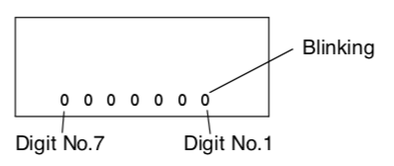

Figure Setting up the theodolite communications

1. Using the ◀ and ▶ buttons to select digits and the ▲ button to change the number, set Digit No. 3 to **1** and the rest to **0**.

|  |
| --- |
| 0 0 0 0 1 0 0 |

1. Press and hold the [0 SET] key on the theodolite keypad and wait until you see ‘SET’ appear on the screen. Turn the power OFF.

# Detailed Discussion on Steps in the SOP

## **Reference Points Determination**

To determine the **vertical reference** point:

1. **Identify:** Choose one or two fixed locations where the waterline meets an immovable object in the prescribed distance.
2. **Obtain Coordinates:** At the base of the chosen object(s), use a handheld GPS to record the latitude and longitude coordinates. Employ waypoint averaging in your GPS.

To determine the **horizontal reference** point:

1. **Identify:** Choose a clearly identifiable, stationary location in the prescribed distance.
2. **Obtain Coordinates:** At the base of the chosen object(s), use a handheld GPS to record the latitude and longitude coordinates. Employ waypoint averaging in your GPS.
3. **Record the Lat/Lon Values:** For entry into Mysticetus.

To determine the theodolite location:

1. **Identify:** Choose a clearly identifiable, stationary location with no obstructed view to your area of interest and reference points.
2. **Obtain Coordinates:** At the center of the theodolite measure the theodolite coordinates. Use a handheld GPS to record the latitude and longitude coordinates. Employ waypoint averaging in your GPS.
3. **Record the Lat/Lon Values:** For entry into Mysticetus. **Theodolite Location Determination:** Determine the precise latitude/longitude coordinates of the theodolite location. Use a high-accuracy GPS device. Document these coordinates and their form, degrees minutes seconds or Degrees decimal minutes.
4. **Set the correct theodolite as your primary vehicle:** Right click on the desired theodolite (assuming there are many theodolite locations in use) and click on “set as primary vehicle”.

Figure Set the desired theodolite location as primary vehicle.

**NOTE:** If your project is a child project the following steps: reference point creation and theodolite definition must be performed in the parent project then deployed to your child project while running Mysticetus in “Advanced” editor mode except where indicated.

## **Create Horizontal and Vertical Reference Points**

The creation of the vital horizontal and vertical reference points in Mysticetus must follow the steps below. In summary the reference points are defined as waypoints which have unique properties – Lat/Lon coordinates and an intuitive name for each.

## **Enabling Waypoint Creation in Mysticetus**

To be able to create waypoints in Mysticetus a slight modification to the Mysticetus toolbar is required. Use the following steps with Mysticetus running in editor mode.

If this step has already been completed skip to the section “**Create Waypoints**”.

To update your tool bar to add the option to create waypoints follow the steps below. This is a one-time action per computer.

1. Choose Configure -> System Options -> Toolbar Buttons which is found in the System tab

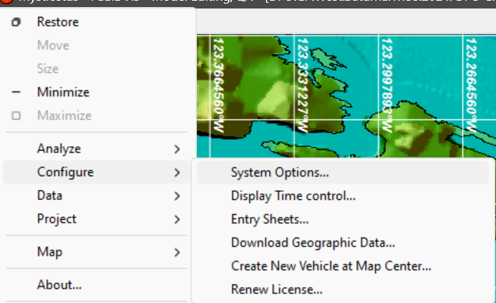

Figure The elipses are often hard to see

1. Scroll down to the display category. Select the ellipses to open the Toolbar configuration window.

Figure "New Waypoint Option is set

1. Enable the Create New Waypoint Toolbar button by clicking the box (this may already be enabled on your computer).

Waypoint Selection Notes:

1. An ideal distance from the vertical reference point should be 50 to 250 meters from the theodolite. But it can be up to 1-2 kilometers.
2. The horizontal reference point should be a fixed, immovable structure (e.g., power pole, piling) at least 500 meters from the theodolite. Farther is better with the horizontal reference point

## **Creating Waypoints in Mysticetus**

1. Quick check - when you hover the cursor over the map, the cursor looks like a small hand on the map you will need to change its mode by clicking “toggle pan” option on the toolbar.

Figure This setting needs to be changed, click the arrow

Figure How this setting should look except to drag map

1. Go back to the map, click the Waypoint toolbar button, this will cause the cursor to change shape. Then click on the map near where the waypoint will ultimately end up. It does not have to be exact.

Figure Click on the create waypoint button then click on the map close to actual location

Figure Actual default waypoint name might be slightly different

1. Right click on the new waypoint icon on the map (you may have to zoom in close to do so), choose Properties

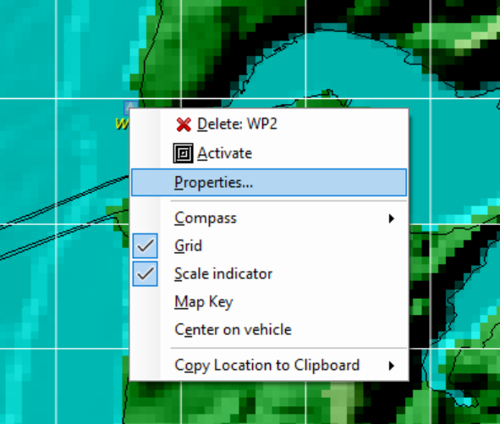

1. In the Properties window on the right, select the Location item, and paste or type in the correct latitude and longitude.

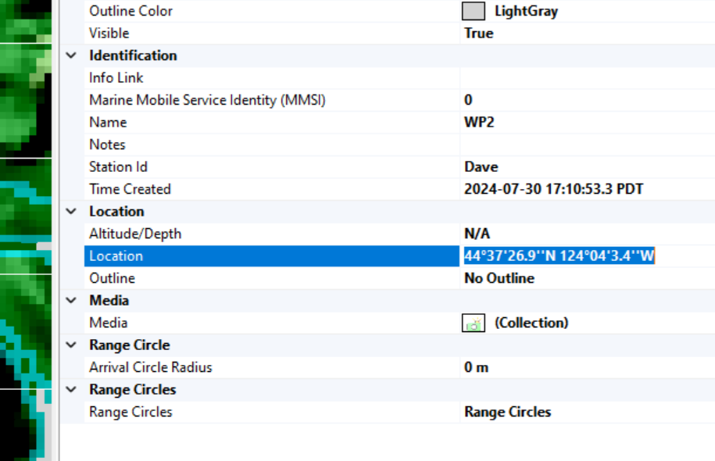

Figure Setting the theodolite location

1. Select the “Name” field in the Location item, and enter a name for the waypoint (such as “Dock 17 Pylon”, “Granite rock vertical”, “Crack in seawall horizontal”, “Lighthouse”, etc. These reference points are what you will use when applying either horizontal or vertical calibrations.

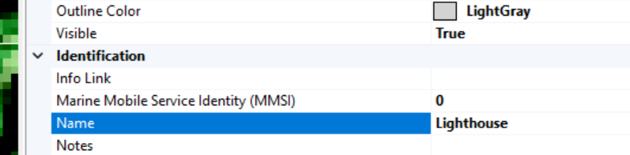

Figure Give the theodolite station an intuitive name

Once the theodolite “vehicle” and respective waypoints have been defined then save the template with these updates.

Click redball->project->”Save Template” and save this new information into your project’s template. Note: the word “Template” must be in your template file name.

If you have been set up in the Grandparent->Parent->child relationship you will, instead, click redball->project->”Save template and deploy to other projects” per the below.

If the current project is the child Mysticetus will not allow this action but will, instead offer to load the parent template.

Figure Deploying to a child project

This will give you the option to deploy to your respective child project or projects as appropriate. Check the correct box and click on the deploy button.

Figure Example child projects, project names redacted.

## **Theodolite Connect, Configure, and Definition Within Mysticetus.**

Theodolite/computer configuration is a daily one-time setup process. However, at the beginning of each day, you must recalibrate your theodolite using the horizontal and vertical reference points.

These calibration steps are further detailed within this document.

1. **Identify Com Port:** In Windows Device Manager, determine the assigned Com port number (e.g., COM5) for the connected theodolite. This information is crucial for configuring Mysticetus.
2. **Configure Mysticetus Port Assignment:** While running Mysticetus in *Editor Mode* and navigate to the "This Machine" tab under System Options, then to the Serial Port Editor. Assign the identified Com port to the theodolite.

**Important:** To maintain consistent Com port assignment, always connect the theodolite's RS232 cable to the same USB port. And verify communication rate of 1200 baud.

Figure Setting the serial port channel and communication parameters

1. Click on OK, you should see it now in the “This Machine” tab per below:

Figure Defining the theodolite communication protocol

1. Note: theodolite communication speed of 1200 Baud is typical for all supported theodolites.
2. Click “Done”

## **Creating a Theodolite in Mysticetus**

The basic steps of setting up a theodolite is to create the theodolite as a **new vehicle**, name it, and input its measured GPS location. For projects set up with the grandparent/parent hierarchy this will be done in the parent and deployed to the child project. Otherwise, you will just do this work in your project file.

First you must define your theodolite (also known as a vehicle) by creating a vehicle and setting its lat/lon location in vehicle properties.

Figure Create Vehicle (theodolite); Red ball -> Configure -> Create New Vehicle

Right clicking on the new vehicle and selecting properties provides the option to name the new vehicle aka theodolite station, input its correct lat/lon location, and name the station ID appropriate to your project, this will be reflected in the data collection naming protocol.

Figure Define key theodolite properties; Name, StationID, and its location

Then set “Label Display” to ZoomedIn”

Figure Set Label Display to define the theodolite on map

Next define the theodolite type in the theodolite tab under configuration per the below.

1. Navigate to the Configuration Theodolite tab indicate which supported theodolite type is in use. Remember, these settings are inherited from the parent in the case where your project lives in a project hierarchy! A screenshot of a computer

   Description automatically generated

Figure Define your theodolite type

1. Selection the correct horizonal reference point in the drop down in the case where you may have several.

Figure Selecting the horizontal reference point

The theodolite interface should be tested whenever the theodolite is reconnected with the Mysticetus computer, typically daily.

Now, if you are running in the project hierarchy mode you must save the project and deploy to the child project.

Figure Redball -> Project -> Save & Deploy

## **Communication Test**

This test is performed while Mysticetus is running in data collection mode.

Validating theodolite communication with Mysticetus is important before you move on to calibrating the theodolite. It works to verify Mysticetus is reading from the theodolite. Enter into the System->Options theodolite tab and you will see the Test Theo button.

Pressing the **Test Theo** button will give you theodolite vertical and horizontal azimuth angles if the connection is correct. It will agree with what is shown on the theodolite built in display if you have not moved the theodolite viewer - it will be very close regardless.

If there is a read error, you will receive an error message similar to the below. This error indicates your need to verify theodolite connection to Mysticetus; proper initialization of the theodolite communication, configuring the theodolite, and its location definition (vehicle).

## **Theodolite Calibration Horizontal Reference (Daily)**

This step zero’s the theodolite’s internal bearing against the horizontal reference point. Zeroing the theodolite to this reference point enables determination of true bearing to a sighting. By using two measured points, theodolite position and the horizontal reference point position Mysticetus calculates true north and leverages the angle between true north and the angle between the reference bearing and bearing to the sighting to calculate the actual angle from true north.

Run Mysticetus in data collection mode to perform this step.

Figure Select the correct location for your current theodolite position

For the daily setting of the horizontal reference point align the theodolite to the ***correct*** horizontal reference location, select that location in the dialog drop down, then press the “zero set” (0 SET) button twice on the theodolite. This step is required daily during setup or whenever the theodolite is moved. Moved could be the case where someone stumbles over the theodolite resulting in movement of the theodolite - when in doubt reset the horizontal reference point.

Figure With correct location selected, theodolite properly aimed, click on the theodolite’s zero (0) set button

Once the horizontal reference point is correctly selected Mysticetus will calculate the distance to it leveraging the horizontal reference point location and theodolite position. Verify distance is correct.

Figure The zero set button on a DT205.

After hitting the “zero set” button twice (for DT205) the horizontal will read out as 0000 - Zeros on the keypad. Make sure your referenced location, when there are multiple reference points, is correctly selected. In the above example a dock edge is the defined reference point.

Next step is to take a sample data point. This data point will show up on the map view which can then be reviewed for correctness – either it is in the right location or clearly wrong. The more prudent operator might consider having an additional waypoint of another known location. The sample reading icon will overlay the waypoint icon if the reading is correct. Creation of waypoints is defined elsewhere in this document.

## **Theodolite Calibration – Altitude Calibration (periodically)**

NOTE: This step is performed periodically throughout the data collection day.

The Vertical reference is a known location at the water line - that is where water meets an immovable object. There may be multiple reference points. This could be a dock pylon, a stick pounded into the bottom sufficiently long to protrude above the water for all tidal conditions (or multiple sticks) or it might be a bridge pylon. What is important is with tidal changes the water does not recede from that object(s). This may not always be possible, hence having multiple objects for reference could be required.

**Periodic updating captures water height change due to tidal action -** this is importantin calculating accurate sighting record distance computation. Again, the update frequency of theodolite height is recommended minimally every 30 minutes except in cases of extreme tidal behavior such as seen in Cook’s Inlet Alaska which is an extreme example.

An ideal distance from the theodolite to the selected object is 50 to 250 meters. But it can be up to 1-2 kilometers.

Figure Running the Altitude wizard courtesy of Scotti-Lynn

NOTE: The theodolite’s indicated vertical angle should never exceed 180 degrees as seen either in Mysticetus or on the theodolite built in display during daily setup. If your angle is greater than that you simply need to rotate theodolite viewing head (aka eye piece)180 degrees, then rotate the theodolite.

Figure Setting theodolite altitude, hit apply once set.

Once you have the theodolite viewer directed at the vertical reference point’s water line hit apply. The updated height will be reflected in calculated height and can be viewed in the theodolite log entry sheet (data tab) if the theodolite logging is enabled (it should be) plus the watchdog will update to reflect the new value.

NOTE: REMEMBER TO HIT **APPLY** BUTTON (Something the author forgot once :-s ).

Mysticetus keeps a watch dog displaying the most recently calculated altitude value. This serves to remind you that it was set, the calculated altitude, and **what time** it was last computed. All especially important points!

Selecting the watchdogs is performed in the dropdown window to the right of the map view.

The watchdog system is extensively discussed in the “Mysticetus PSO and Lead PSO QA QC Guide” available at <https://mysticetus.com/downloads>.

## **Change Logging – Recording Theodolite Height Updates**

Having the option to “**Log Changes**” set to true will guarantee your updates to theodolite altitude calculation will be a recorded in Mysticetus. This feature’s use is strongly recommended.

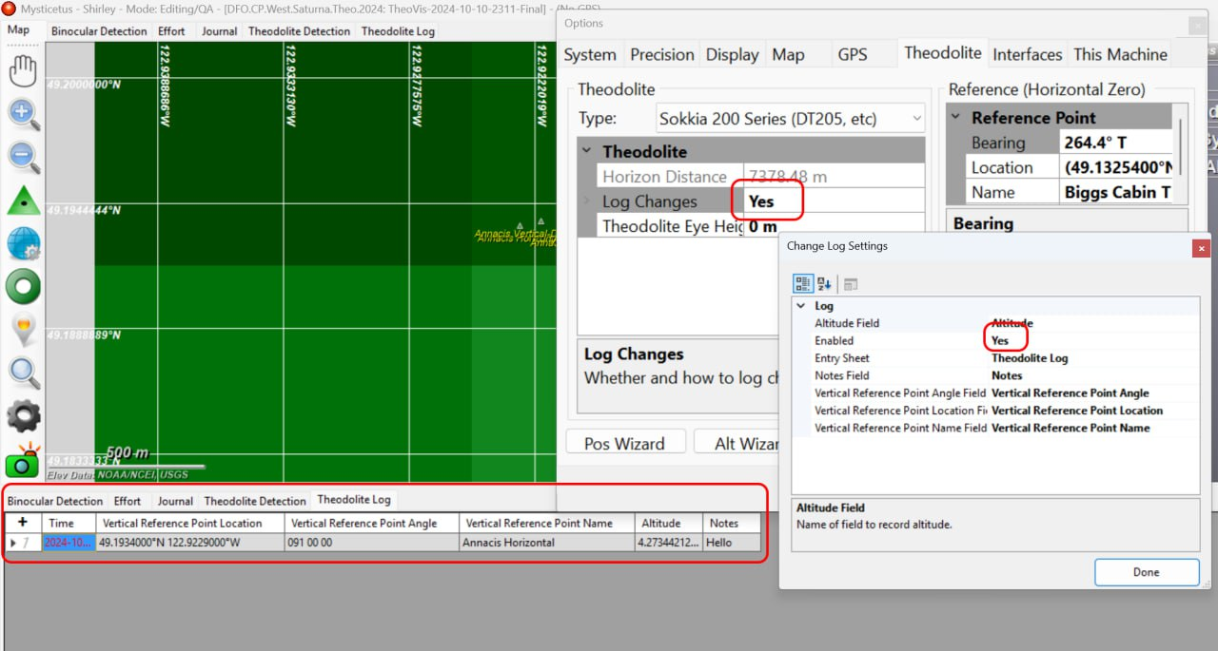

The above “Change Log Settings” arguments (eg fields, entry sheet) must strictly represent the arguments that you need to input information too.

1. It is literal, typos will render that field non-functional.
2. Mistype the entry sheet (aka tab seen in data collection mode) name and it will not write out the data.
3. Mistype a field name and it will not write out the value.

In this example the entry sheet (or tab) titled “Theodolite Log” is where calibration data is written out to per the above image. If we have helped you create your project up it should be the same.

Again, all set values in the Change Log Settings dialog must be exact to what is seen in the Theodolite Log. When in doubt, check your spelling!

Figure Change logging should be enable during project creation with Mysticetus help.

Note: Change Log Settings **are set in the Grandparent** for projects in the hierarchal structure.

Now you are ready for data collection!

## **Troubleshooting Erroneous readings**

Sometimes calibrations are not correct. Once Mysticetus is properly communicating with the theodolite and you have taken a reading whose result is clearly wrong you need to check you calibration points.

* 1. Bearing is wrong: horizontal reference point calibration or the latitude/longitude values are incorrect
  2. Distance is wrong: Computed theodolite height above water is wrong. Rerun the altitude wizard. If this fails verify the latitude/longitude values of the location of the vertical reference point.

## **Important points for theodolite operation**

* Orientation of the theodolite viewer. When the theodolite is pointing straight up it should read zero, 0, degrees. When straight down it should read 180 degrees.
* **Your vertical angle should never be greater than 180 degrees.** This is an easy mistake. Simply spin the viewer and rotate theodolite around to fix.
* When determining Lat/Lon of your reference points with a GPS using the waypoint feature in your handheld GPS set the waypoint averaging setting. This eliminates GPS “bounce” in your reference value within a few feet or less.
* Using multiple waypoints for your horizontal reference point is recommended, but not required in the case of possible obscuration by weather, sudden arrival of construction material, wind, etc.
* Multiple vertical reference points must be provided in the case where the water level can recede away from a given reference point.

# Technical Discussion on Reference Points, The Why

## **Vertical Reference Point Discussion**

Accurate theodolite measurements rely on establishing dependable vertical (also referred to as altitude) reference point(s) – multiple points can exist. A vertical reference point is a fixed location where the waterline intersects a stationary object. Suitable examples include a dock pylon, a firmly planted stake or series of stakes extending above the high-tide mark, or a bridge support. Ideally, this point should be located 50 to 250 meters from the theodolite, although distances up to 1-2 kilometers are acceptable.

The altitude reference, accounting for tidal fluctuations, should be refreshed typically between 15 and 30 minutes. However, in areas with significant tidal changes, such as Alaska's Cook Inlet, more frequent updates are necessary. Conversely, locations with minimal tidal activity may require less frequent adjustments. While a 30-minute interval is typically acceptable, users must determine the appropriate frequency based on the specific tidal conditions of their operational area.

A critical consideration when selecting the distance to the vertical reference point is the potential for error propagation. As the distance increases, the vertical angle change (capturing tidal fluctuation) measured by the theodolite becomes smaller. This shallow angle change, combined with manufacturer tolerances in the theodolite's vertical angle measurement, can induce error in the calculated altitude. Since the vertical reference point plays a key role in distance calculation, inaccuracies in this measurement can impact accuracy of results. Therefore, careful selection of the vertical reference point distance is crucial for minimizing errors when measuring small tidal changes.

## **Horizontal Reference** **Point Discussion**

The horizontal reference point is a crucial element for determining accurate bearing to sightings. This point, located at a known distance, establishes a reference bearing. By using the known coordinates of both the theodolite and the horizontal reference point, Mysticetus calculates true north. This allows the system to determine the angle between true north and the reference bearing. By combining this angle with the angle measured between the reference bearing and the bearing to the sighting, Mysticetus calculates the true heading (bearing) from true north to the sighting.

Figure Horizontal reference point sketch courtesy of Scotti-Lynn

Mysticetus uses the following calculation to determine the true heading (β) to a sighting:

β = (θ + τ) modulo 360

Where:

* **θ:** Represents the angle between true north and the reference bearing.
* **τ:** Represents the angle measured by the theodolite between the reference bearing and the bearing to the sighting.
* **Modulo 360:** Ensures the resulting angle (β) remains within the 0-360 degree range. This manages cases where the sighting angle (τ) is less than the reference angle (θ), preventing negative or overly large angle values.

Horizontal Reference Point Selection: For optimal accuracy, the horizontal reference point should be a fixed, immovable structure (e.g., power pole, piling) at least 500 meters from the theodolite. Shorter distances can introduce inaccuracies.

Ensure an unobstructed line of sight exists between the theodolite and the specific, clearly identifiable point. This point, once chosen, must be used consistently daily for zeroing the theodolite.

Reference: [Bowditch's_American_Practical_Navigator](https://en.wikipedia.org/wiki/Bowditch%27s_American_Practical_Navigator) - dig in here to discover the derivative math.

## **Additional Setting Options for DT205:**

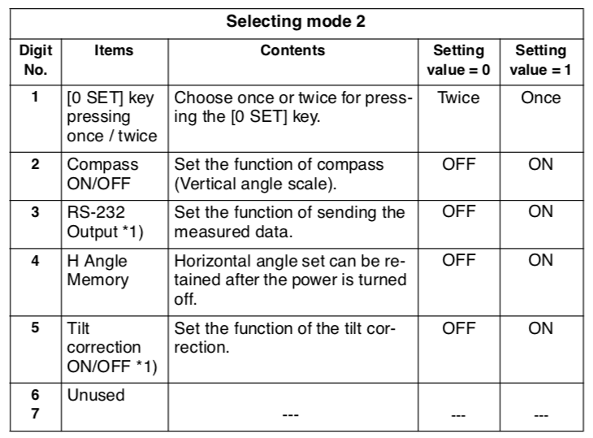

## **Theodolite Manuals**

We have manuals for the DT200 series, DT510 series, and DT5 series theodolites if you cannot find them online. Just ask.

## **References**

* Mysticetus Project Manager Operations Guide - <https://www.mysticetus.com/downloads>
* Mysticetus PSO/Lead PSO Operations Guide - <https://www.mysticetus.com/downloads>
* Math derivation for distance calculations - [Bowditch's_American_Practical_Navigator](https://en.wikipedia.org/wiki/Bowditch%27s_American_Practical_Navigator)
* Theodolite use research paper, Alaska - <https://www.frontiersin.org/journals/marine-science/articles/10.3389/fmars.2019.00710/full>
* Theodolite use research paper Gulf of Mexico - <https://www.mdpi.com/2076-2615/13/22/3441>

## Appendix

### Checklists –

The below checklists assume full understanding of the Theodolite Configuration Manual and serves as tool to guide through daily operational steps.

**One-Time Per Project Setup:**

* **Project Hierarchy:** Verify and understand the created Mysticetus project hierarchy.
* **Theodolite Communication:** Configure the theodolite's communication settings (RS232, 1200 baud). This is a one-time setup per theodolite.
* **Reference Points:**
  + **Establish:** Define precise vertical and horizontal reference points.
  + **Coordinates:** Acquire accurate GPS coordinates for each reference point.
  + **Document:** Record these coordinates.

**Mysticetus – Run Advanced Editor Mode:**

* **Waypoints:** Create waypoints in Mysticetus for each reference point, using acquired coordinates and descriptive names.
* **Theodolite Definition:** Create the theodolite as a "Vehicle" in Mysticetus, inputting its location coordinates.
* **Theodolite Configuration:** Configure the theodolite's communication settings (COM port, baud rate) in the "This Machine" tab.
* **Theodolite Type:** Select the correct theodolite type in the Theodolite tab.
* **Horizontal Reference Point Selection:** Choose the correct horizontal reference point in the dropdown menu.
* **Change Log Settings:** Enable change logging and configure the appropriate fields and entry sheet ("Theodolite Log").
* **Save & Deploy:** Save the parent project and deploy changes to the child project(s).

**Mysticetus Daily Operation Setup and Data Collection Checklist**

* **Data Collection Mode:** Ensure Mysticetus is running in Data Collection mode.
* **Select Theodolite Station:** Select the correct theodolite station during Mysticetus startup.
* **Position Theodolite in exactly the same physical location:** This is for the theodolite station selected above.
* **Theodolite Calibration:**
  + **Horizontal Reference (Zero Bearing):** Aim at the horizontal reference waypoint and zero the instrument using the zero-set button (press twice).
  + **Altitude Calibration:** Use the Altitude Wizard to calculate and apply the theodolite eyepiece altitude (point to vertical reference point).
* **Test Reading & Verification:** Take a test reading and verify its accuracy on the map and detection sheet. Review the previous steps if discrepancies exist.
* **Data Collection:** Begin taking readings. Monitor data quality via map display and instrument stability.
  + **NOTE:** All vessel/animal readings are taken where the object meets the water.
* **Vertical Reference Point Updates:** Update the vertical reference point at least every 30 minutes to account for tidal changes (adjust frequency as needed).
* **Data Management:** Data is stored securely within Mysticetus and on your computer. Regular backups occur automatically.